IFIN EOI published in All Editions of Economic Times + Dinakaran – Chennai on 07/02/2025

Economic Times – all editions |   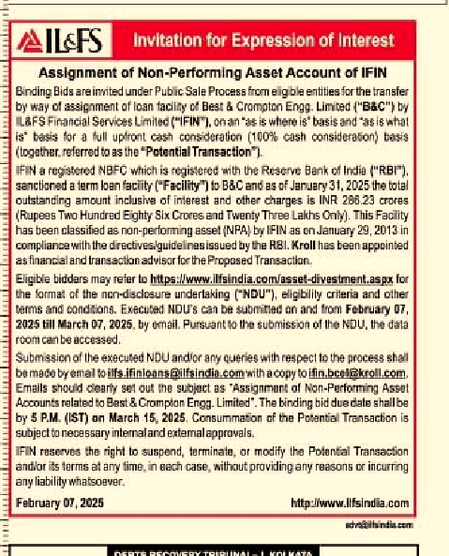
Dinakaran – Chennai | 